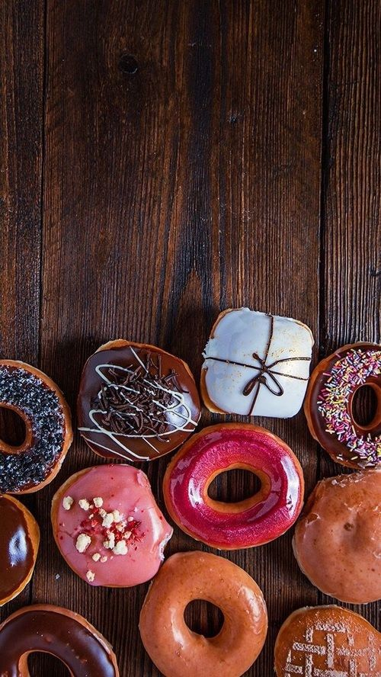

**CAKE**

**MAKER**

DOCUMENTATION

**PROJECT**:  **CAKE MAKER**

**GROUP MEMBERS:**

|  |  |
| --- | --- |
| **GROUP MEMBER** | **ENROLLMENT.NO** |
| **Muhammad Taha Arif** | **STUDENT 1106210** |
| **Ahsan Saleem** | **STUDENT 1104801** |
| **Mahnoor Sadiq** | **STUDENT 1105265** |
| **Khizar Imtiaz** | **STUDENT 1104802** |

**FACULTY:** MISS AATIKA LIAQUAT

**BATCH CODE:** 1805C1

**CURRICULUM:** 6673

**SEMESTER:** HDSE-II



**Table of Contents:**

1. Acknowledgment..................................................................................................................... 4
2. Declaration……………………………………………………………………………………………………….……… 4
3. Certificate…………………………………………………………………………………………………………….…. 5
4. CHAPTER 1: INTRODUCTION……………………………………………………………………………….….…. 7
5. Problem Statement………………………………………………………………………………..… 7
6. Need of Project………………………………………………………………………………………… 9
7. CHAPTER 2: PROJECT MAKING & BACKGROUNDS……………………………………………..…… 10
8. Project Duration…………………………………………………………………………………………. 11
9. Task Sheet……………………………………………………………………………………………...…... 12
10. CHAPTER 3: SOFTWARE & HARDWARE REQUIREMENTS………………………………………….. 13
11. Hardware Requirements………………………………………………………………………..……. 14
12. Software Requirements……………………………………………………………………………..… 14
13. CHAPTER 4: WORKFLOW SUBMISSION CHECKLIST……………………………………………….… 15
14. Workflow Submission Checklist…………………………………………………………………….... 16
15. CHAPTER 5: Screenshots……………………………………………………………………………………,,… 17
16. CHAPTER V: CONCLUSION………………………………………………………………………………..,,,,…. 28
17. Remarks………………………………………………………………………………………………………,,,,.. 29
18. Problem Faced…………………………………………………………………………………………………. 29
19. Future Enhancement………………………………………………………………………………….……. 29

1- **Acknowledgement:**

**We would want to appreciate and thank all of those people who helped us during this journey of completing our project. Without everyone’s support, we could not have accomplished our work.**

**We express our sincere gratitude to our faculty “--Miss Aatika Liaquat--" and our coordinator for their amazing support and guidance, continuous encouragement and supervision throughout the course of the present work. It’s of no doubt that we have been very fortunate to work under such a supportive and cooperative teacher/coordinator**

**And last but not the least we are extremely grateful to the whole faculty and administration of Aptech, for providing us all the facilities that were mandatory, without which this project could not be a success.**

2- **Declaration:**

**We are writing this to declare that all the work which is being written bellow in this Project Report entitled “— CAKE MAKER--” is a veritable record of our own work submitted to the Aptech NN, Karachi, Pakistan during the year 2020 in the partial fulfillment of semester IV (HDSE II) project We also declare that we have not submitted the material being presented in this Project Report for the award of any other degree elsewhere.**

**Signatures:**

**MUHAMMAD TAHA ARIF** **STUDENT 1106210**

**AHSAN SALEEM** **STUDENT 1104801**

**MAHNOOR SADIQ** **STUDENT 1105265**

**KHIZER IMTIAZ** **STUDENT 1104802**

**Certificate:**

**This is to certify that,**

**Mr. Muhammad Taha Arif**

**Mr. Ahsan Saleem**

**Mrs. Mahnoor Sadiq**

**Mr. Khizar Imtiaz**

**Has successfully Designed & Developed**

**“CAKE MAKER”**

**Date of Issue:**

**25th-JULY-2020**

**Date of Submission:**

**24th-AUGUST-2020**

**Authorized Signature: Miss Aatika Liaquat**



**CHAPTER 1**

**INTRODUCTION**

**PROBLEM STATEMENT**

**Introduction**

The main purpose is to create an informative, interactive and business website for Cake manufacturers. The brand name is “The Cake” and the shop is located all over the country. The website has to be informative enough for the end users / viewers to know brief of the various products and its prices and the availability.

**Functional Requirements**

The website should cover the following links / pages:

1. **Home page:** The page should be designed with a banner at the top of the page. The home page should cover a brief description of the entire website / presentation as well as a brief history of cake.
2. **About us:** divide the page into three sections vertically. Provide the foundation, mission and vision on these sections.
3. **All products:** the product page should be designed with all the products / thumbnails along with brief details of the individual products, such as
   1. item code
   2. Price
   3. Egg less/with Egg
   4. order button
4. On click on the order button a purchase form page should appear on a new browser window. The purchase form page should have all the form fields to capture the entire transaction and the users' details like
   1. Name
   2. Address
   3. Contact number
   4. Item code
   5. Quantity
   6. Delivery address
   7. Delivery Date
5. On click on the zoom button an enlarged image of the same product should appear on a new browser window.
6. **Products by event:** provide a categorized sub-navigation on this page such as
   1. Birthday
   2. Anniversary
   3. Engagement
   4. Marriage and so on.

Each and every sub-navigational button should be linked to an individual page. All the individual page should be designed with selected / categorized thumbnails along with brief details of the individual products, such as item code, price, zoom and order button.

1. **Store location:** The page should have the of searching the store as per the user’s preference. It should display all the details of the store.
2. **Site Map:** The site map page should contain the entire navigational structure / diagram in a visual form and all the links (page names) of the diagram should be programmed for hyperlink to the respective pages.
3. The administrator should be able to add/update/delete the various products and user details.
4. User should also be able to create the account and track all his orders.

**NEED FOR PROJECT**

Some of the benefits of Project are as under: -

* Re-enforcement of Skills happens in the experiential learning process.
* A mentor, ensuring that you do not get drifted, constantly guides you.
* It gives you a lot of confidence to face an interview as you have worked on a project. You can explain virtually everything on the subject you have learnt.
* A nice, final, black, hardbound report adds to you credentials and enhances your job prospects.
* Projects is compulsory (Sem-End Project) and is supposed to be done over and above the assignments given in your course books.
* It is advised that if a student follows the projects and submits Assignments, he would definitely have an edge over other students.
* Students need to submit their project report along with working application and source code in the stipulated time.



**CHAPTER 2**

**PROJECT MAKING & BACKGROUND**

**PROJECT DURATION**

* + - 1. **ANALYSIS - 1 DAY**
      2. **DESIGN - 10 DAYS**
      3. **DEVELOPMENT - 15 DAYS**
      4. **TESTING - 2 DAYS**
      5. **DOCUMENTATION - 2 DAYS**

|  |  |  |  |  |
| --- | --- | --- | --- | --- |
| Analysis | Design | Database | Testing | Documentation |

|  |  |  |  |  |  |  |  |  |  |  |  |  |  |  |  |  |  |  |  |  |  |  |  |  |  |  |  |  |  |
| --- | --- | --- | --- | --- | --- | --- | --- | --- | --- | --- | --- | --- | --- | --- | --- | --- | --- | --- | --- | --- | --- | --- | --- | --- | --- | --- | --- | --- | --- |
| 1 | 2 | 3 | 4 | 5 | 6 | 7 | 8 | 9 | 10 | 11 | 12 | 13 | 14 | 15 | 16 | 17 | 18 | 19 | 20 | 21 | 22 | 23 | 24 | 25 | 26 | 27 | 28 | 29 | 30 |

**TASK SHEET**

|  |  |  |  |  |  |
| --- | --- | --- | --- | --- | --- |
| **NO.** | **TASK** | **ACTUAL START DAYS** | **ACTUAL DAYS** | **NAMES** | **STATUS** |
| 1. | CASE STUDY | 25th JULY  2020 | 2 | MUHAMMAD TAHA ARIF,  AHSAN SALEEM,  MAHNOOR SADIQ,  KHIZAR IMTIAZ | COMPLETED |
| 2. | UI DESIGNING | 26th JULY 2020 | 9 | MUHAMMAD TAHA ARIF,  KHIZAR IMTIAZ,  MAHNOOR SADIQ. | COMPLETED |
| 3. | SCENARIO MAKING | 29th JULY 2020 | 8 | KHIZAR IMTIAZ,  AHSAN SALEEM,  MAHNOOR SADIQ | COMPLETED |
| 4. | MATERIAL SEARCHING | 14ST AUG 2020 | 3 | MUHAMMAD TAHA ARIF,  AHSAN SALEEM,  KHIZAR IMTIAZ | COMPLETED |
| 5. | DATABASE CONNECTIVITY | 17th AUG  2020 | 6 | AHSAN SALEEM,  MAHNOOR SADIQ | COMPLETED |
| 6. | DOCUMENTATION | 23th AUG 2020 | 2 | MUHAMMAD TAHA ARIF | COMPLETED |



**CHAPTER 3**

**HARDWARE &**

**SOFTWARE**

**REQUIREMENTS**

**HARDWARE REQUIREMENTS**

1. **A minimum computer system that will help you access all the tools in the courses is a Pentium 166 or better.**
2. **64 Megabytes of RAM or better.**

**SOFTWARE REQUIREMENTS**

1. **VISUAL STUDIO CODE**
2. **XAMPP**
3. **GOOGLE - BROWSER**



**CHAPTER 4**

**WORKFLOW SUBMISSION CHECKLIST**

**WORKFLOW SUBMISSION CHECKLIST**



|  |  |  |  |
| --- | --- | --- | --- |
| **S.NO** | **LIST OF ITEMS** | **Remarks** | **COMMENTS** |
| 1. | ARE ALL PAGES LINKED TOGATHER? | **YES** | THROUGH THE URL. |
| 2. | IS THE DATABASE CONNECTED? | **YES** | USING MySQL. |
| 3. | ARE THE PAGE COLOURS ACCORDING TO THE GUIDELINES? | **YES** | USED PROFESSIONAL COLOR COMBINATIONS. |
| 4. | ARE THE TABLES WORKING? | **YES** | CRUD OPERATIONS – IN OPERATION. |
| 5. | IS THE DOCUMENTATION INCLUDED? | **YES** | ALL DOCUMENTS-USER GUIDE, DEVELOPER GUIDE & DOCUMENTATIO. |
| 6 | IS THE PROJECT COMPRESSED? | **YES** | CREATED USING WIN ZIP-RAR. |



**CHAPTER 5**

**SCREENSHOTS**

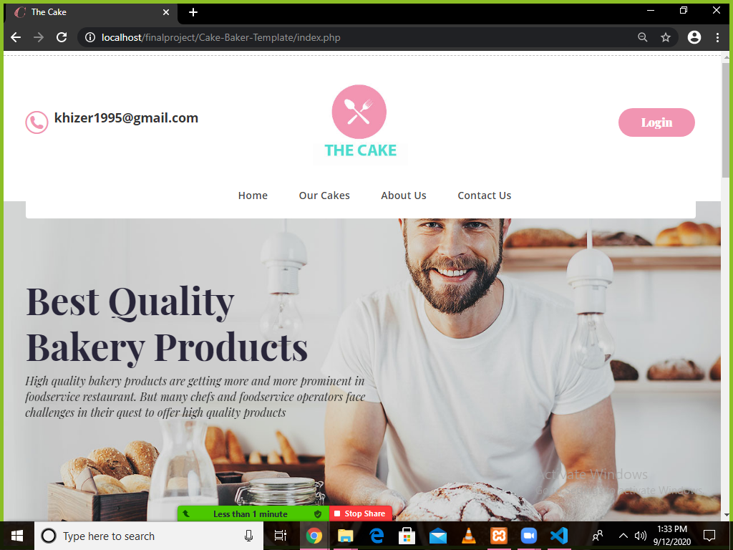

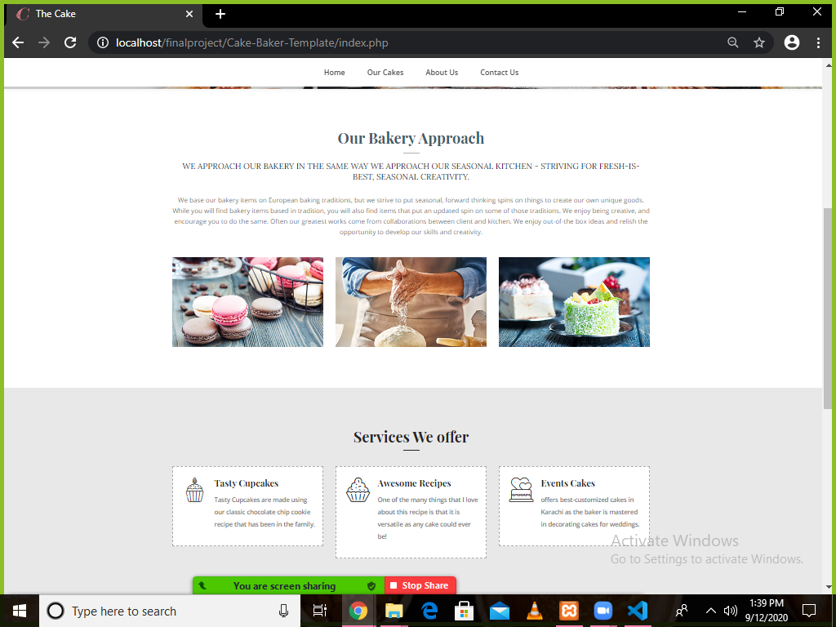

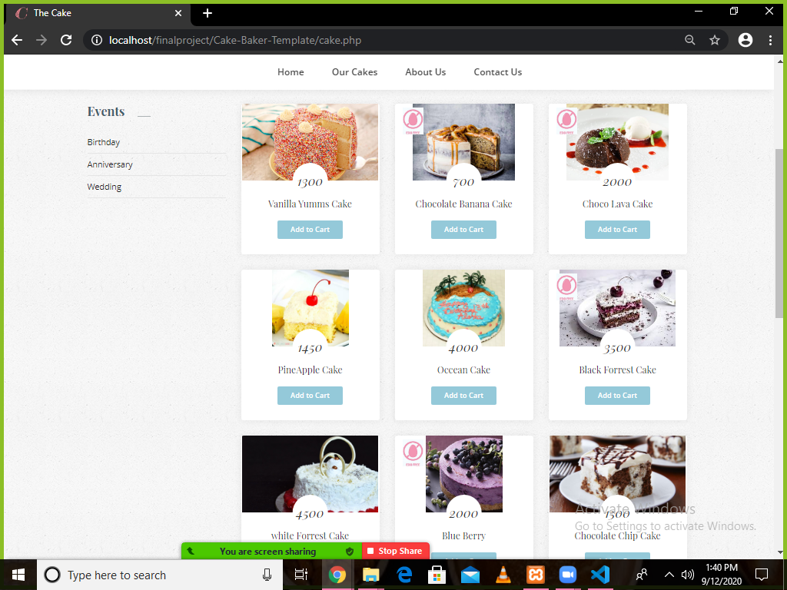

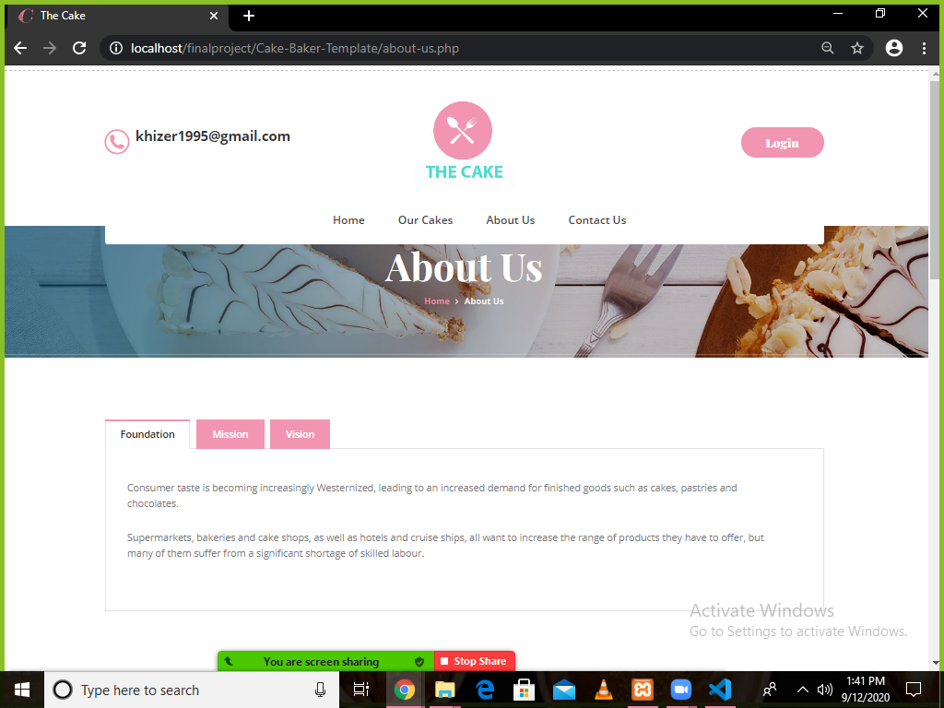

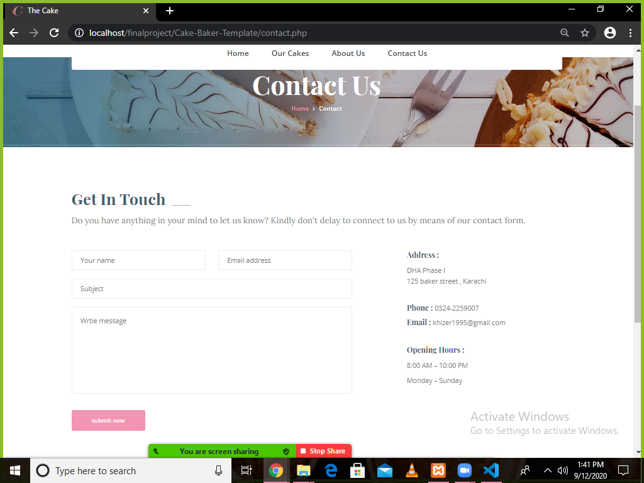

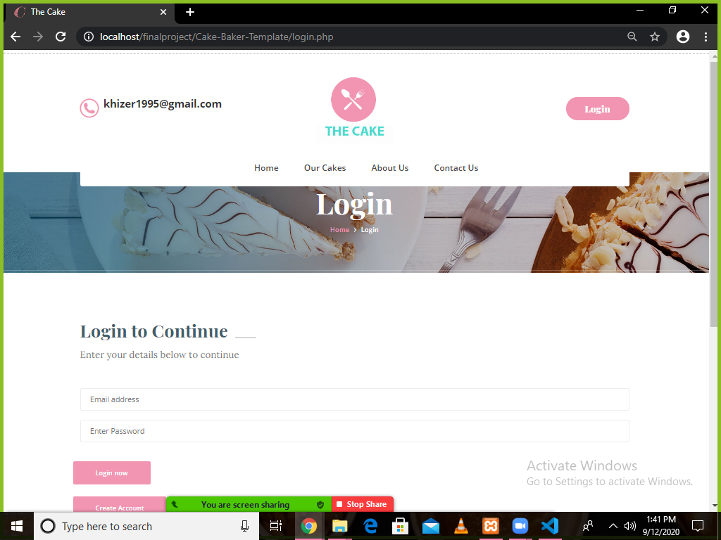

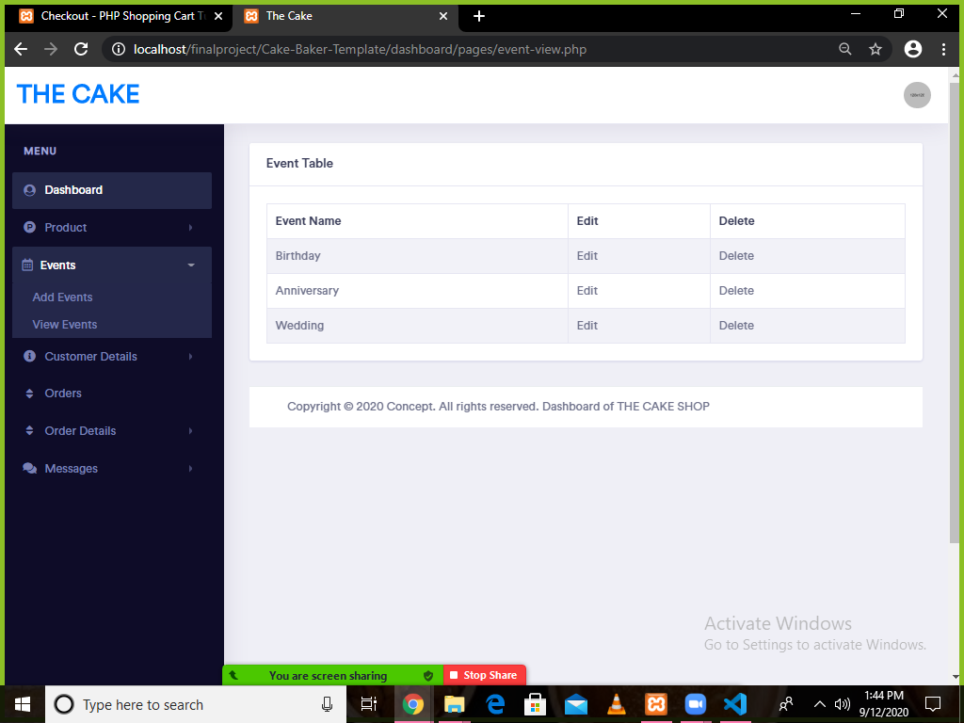

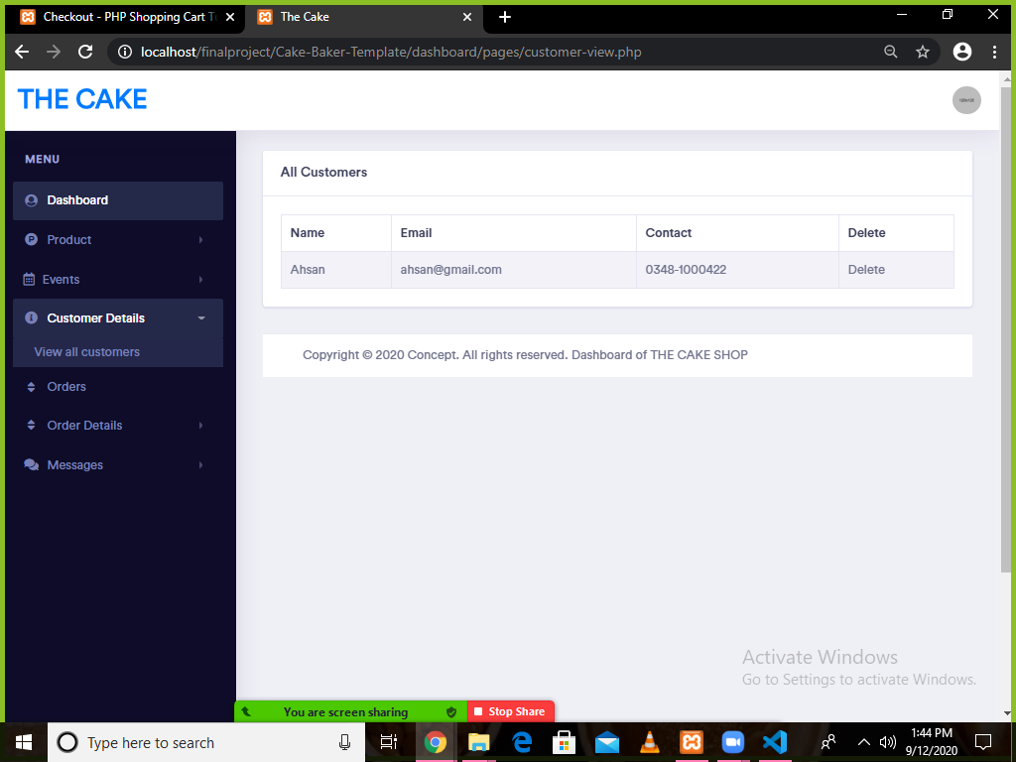



**CHAPTER 6**

**CONCLUSION**

**REMARKS**

- It’s a great initiative helping us not only to bind the members as a strong team but also to polish our technical skills, for the things we have just learned. This gives us the courage to compete at a greater stance.

**PROBLEMS FACED**

- The pandemic situation made it impossible to work, however; we accomplished through countless hours of working online.

**FUTURE ENHANCEMENTS**

- We have worked really hard to transform it into a realistic Cake Shop, making it a better prototype of it. It can be deployed for future use.

- But there is always a place for betterment so ere are our few suggestions, Enclosures will be added soon. Also, interaction with our regular customers can be maintained using mail, message etc.